**44563-01 LAB 11**

**Siddhartha Sangani**

**S569434**

**919646290**

**GitHub repo link:** [**https://github.com/SiddharthaSangani/s24db34sangani.git**](https://github.com/SiddharthaSangani/s24db34sangani.git)

**Rendered server link:** [**https://s24db34sangani.onrender.com**](https://s24db34sangani.onrender.com)

**Screenshot 1**

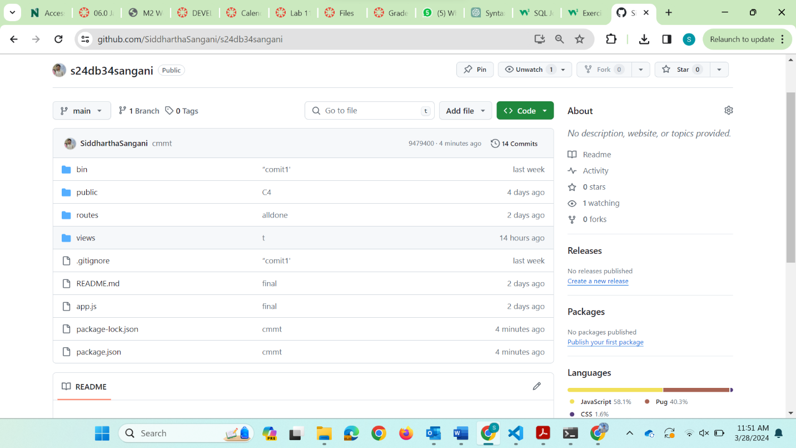

**Screenshot 2**

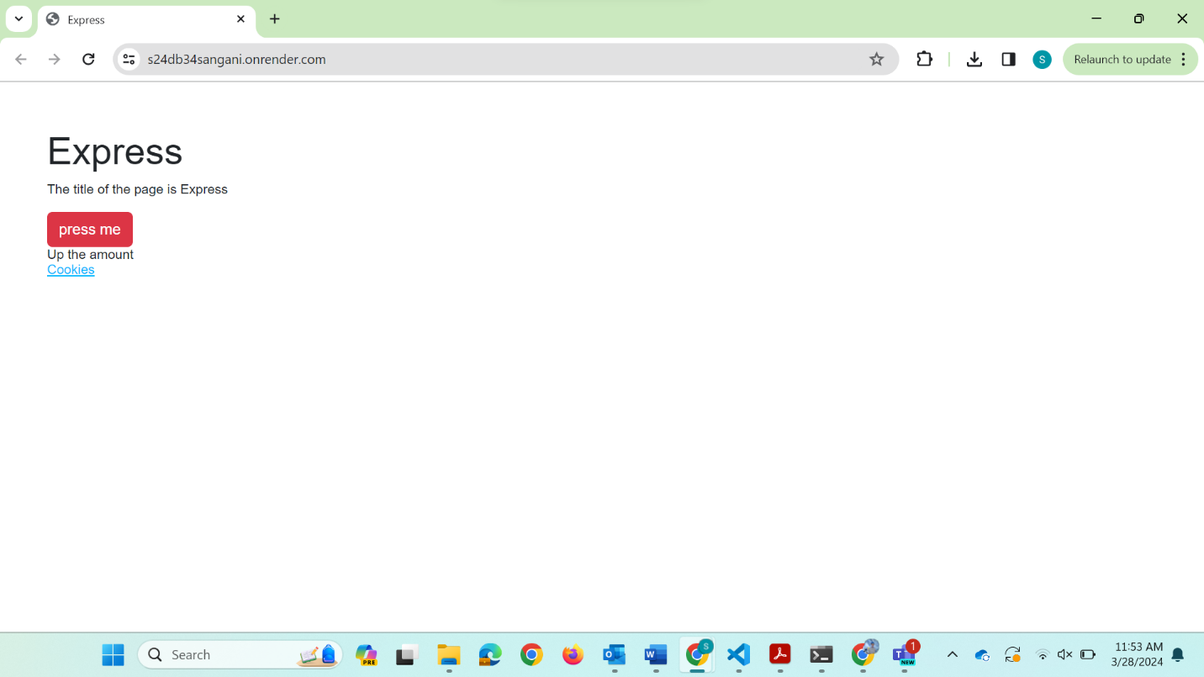

**Screenshot 3**

